**Distance** 1.25 miles

CREWKERNE INTRODUCTORY TOWN TRAIL

**Time** 1hr 15 mins

**Description:- An introduction to the main points of interest in the town centre.**

**Start/End**:- Market Square

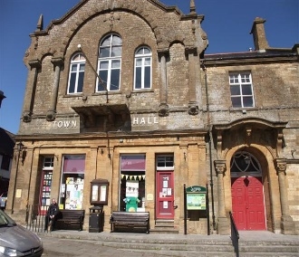

There is no better introduction to Crewkerne than to stand on the steps of the Town Hall and look at the surrounding Market Square.

Although the town is predominately Georgian, virtually every architectural period from Mediaeval times (TheWhite Hart) through to the 20th century (London House) is represented here.

​

During the next hour or so you will be guided to similar fascinating corners of the town. On your route look out for Blue Plaques. They will provide you with more information on the history or architecture of the more notable buildings and associations.

On the right hand side of the Town Hall you will note the handsome carved Hamstone Plaque commemorating the visit of Her Majesty Queen Elizabeth & The Duke of Edinburgh during her Diamond Jubilee Year. This handsome plaque was carved by local lad, Chris Berridge, who was a winner of the Team UK (Stonemasonry) Gold Medal at Workskills London 2011.

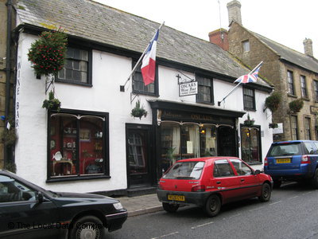

Now turn and walk on the left-hand side of the Town Hall, you will notice Oscar's Wine Bar. Behind its 19th century shop front there is a much older building with 15th century woodwork and a cellar which is possibly 12th century.

After a short distance turn left into Abbey Street. This is a most attractive mid-19th century street with a mixture of styles and uses including early industrial buildings. The old shirt factory on the left now converted into modern loft style apartments whilst retaining the listed 19th Century facade.

Walk past the 17th century Church Hall (the old Grammar School) and down the hill to the picturesque area known as Pople’s Well. This is a quiet backwater on the edge of town with good views of the church.

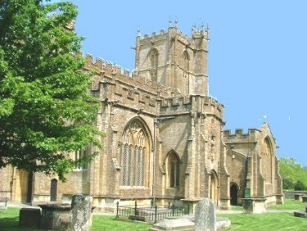Retrace your steps and turn right at the Church Hall into the churchyard. Pause for a while and take a closer look at St Bartholomew's, the town’s impressive 15th century church. For a detailed description of the church please consult the Church Guide obtainable from the church. Continue round the churchyard path noting the fine west front and turn right in Church Path.

At the junction with the main road turn right again into Gouldsbrook Terrace and then cross over (beware traffic). The terrace dates from 1841 when a highway improvement linked the Chard Road with Church Street.

 At the junction with the Chard Road notice Lyewater descending to the right. This is the old road to Chard and it still looks like the old photographs taken in the 19th century.

Turn sharp left into West Street, a street of 19th century artisan housing with the Jacobean style Chubb’s Almshouses on the corner with Court Barton. Turn left into Court Barton, another picturesque part of the town with 18th century houses set around a triangular ‘square’.

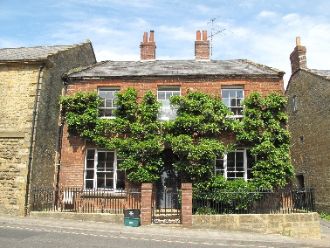

At the end of Court Barton turn right and proceed into Church Street, noting Church Steps on the left with views to the church. Church Street has some of the finest Georgian houses in Crewkerne, and, despite being in the town centre, few have been spoilt by the addition of shop fronts. Hilt House (No. 20) is a particularly good example.

At the bottom of the street, turn right into Market Street, the main shopping area of the town. The street is lined with 18th and 19th century buildings, although you have to look above the shop fronts to appreciate the architectural details.

Cross at the Pelican crossing into Falkland Square. This shopping precinct was developed in the 1970s and is an important focal point of the town. The Public Library, Henhayes Recreation Ground, the Henhayes Community Centre, the Aqua Centre (public swimming pool) with the Active Lifestyle Centre, the George Reynolds Sports Centre, Supermarkets, toilets and the main shoppers’ car park are all located just off the precinct.

Mid-way into the precinct, turn left and follow the pedestrian walkway into the George Precinct. This precinct was opened in 1987 and provides additional shopping in what was the rear wing and courtyard of the George Hotel. Turn left and then on through the archway into Market Square.

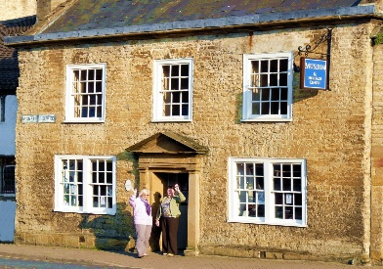Turn right to visit the Heritage Centre and Museum (open Wednesday to Friday from Easter to October) which is set in an attractive Georgian House with a much older building behind. The Heritage Centre and Museum houses an interesting collection of local artefacts, photographs, maps and documents, with periodic special exhibitions on topics of local interest.

Then proceed 100 yards along East Street and cross over to Merefield House, one of the grandest houses in Crewkerne. It has a Regency style front, Greek revival porch, armorial gates and a unique Gazebo in the grounds. Orchard Lane across the road gives a good viewing point for the Gazebo. Return to the town centre passing many more interesting Mediaeval, 18th and 19th century houses along the way.

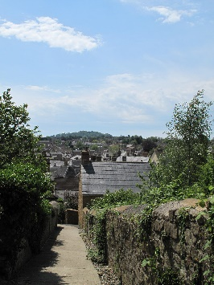

Once back in Market Square turn right into Bincombe Lane in the north-eastern corner. A short way to the left is a steep path which leads to Bincombe Hill which is managed by the Town Council as a nature reserve. The fine panoramic view of the town from the top makes the short climb worthwhile. You should be able to pick out some of the buildings and streets you have visited and it’s a good place for a rest and a picnic! From the other side of the hill looking north, there is a fine view of the Quantocks, Poldens and Mendips. Watch out for the wood carvings as you walk the pathways!

